PROJECT PROPOSAL (SYNOPSIS)

INDIRA GANDHI NATIONAL OPEN UNIVERSITY

BCSP-064

ON

ONLINE BOOKSTORE MANAGEMENT SYSTEM

By

Shivani (186484872)

UNDER GUIDANCE

OF

Mr. Akash Porwal

Submitted to the Shyamlal College (0769) in

Partial fulfilment of the Requirements for the degree of

Bachelor

Of

Computer Applications



Indira Gandhi National Open University

MaidanGarhiNew Delhi-110068

Table of Content

|  |  |  |
| --- | --- | --- |
| S.NO. | CONTENT | PAGE NO. |
| 1. | Title of the Project |  |
| 2. | Introduction and Objectives of the Project |  |
| 3. | Project Category |  |
| 4. | Analysis |  |
| 5. | A complete structure |  |
| 6. | Tools / Platform, Hardware and Software Requirement specifications |  |
| 7. | Are you doing this project for any Industry/Client? |  |
| 8. | Future scope and further enhancement of the project. |  |

**TITLE OF THE PROJECT**

**Online BookStore Management System**



**1.1 INTRODUCTION**

Almost in BOOKSTORE MANAGEMENT the records of members, New book Entry, their details, Member Entry, member Enquiry, Book Enquiry, Book Return register etc. are maintained and manipulated. Generally all these works are done and managed manually hence leading to the chances of human errors that may create some problems. Thus, a secured and reliable

System is required to handle it. In **ONLINE BOOKSTORE MANAGEMENT SYSTEM**, as described above, can lead to error free, secure, reliable and fast Information system. It can assist the staff to concentrate on their other activities rather to concentrate on the record keeping. Thus it will help organization in better utilization of resources.

The organization can maintain computerized records without redundant entries. That means that one need not be distracted by information that is not relevant, while being able to reach the information that is relevant much more quickly.

**2.1 OBJECTIVE OF THE PROJECT**

This project deals with the information criteria of the ONLINE BOOKSTORE MANAGEMENT SYSTEM Basically the project describes how to manage for records of Books, searching of book.

The main objectives behind the development of this project are as

Follows:

- To utilize the information of Books.

- To store and retrieve books items.

- To manage records of students who

- To store and access item in books stocks.

- To manage the particular records of student.

- To generated the report of books.

- To provide the details of issue books

Thus, there are a number of objectives behind developing the “ONLINE **BOOKSTORE MANAGEMENT SYSTEM**" and it reduces a lot of manual working of the department

3. Project Category:

This project **“ONLINE BOOKSTORE MANAGEMENT SYSTEM*”*** falls in the category of Relational Database Management System (RDBMS) project**.** This project aims to provide improved functionality and better user interactive environment. With **“HTML, CSS, JS, jQuery, BootStrap”** as a Front End and Servlet and MySQL as a Back End.

**4. Analysis**

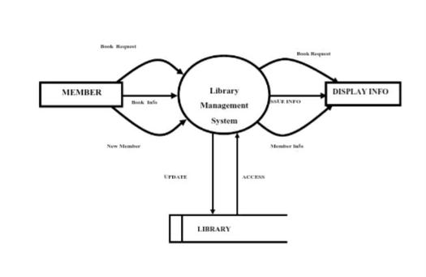**Data Flow Diagram**

**: - Zero Level DFD (CONTEXTUAL DIAGRAM)**

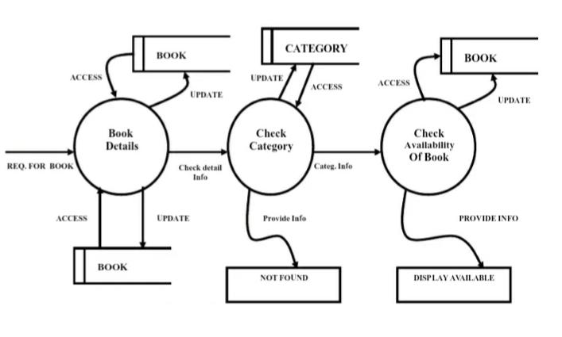

**: - First level DFD**

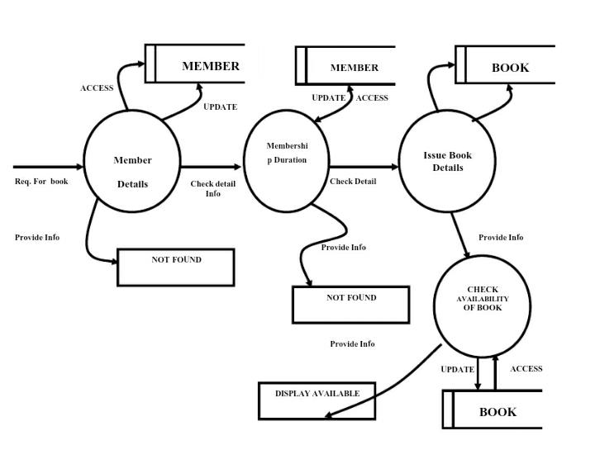

**: - Second level DFD**

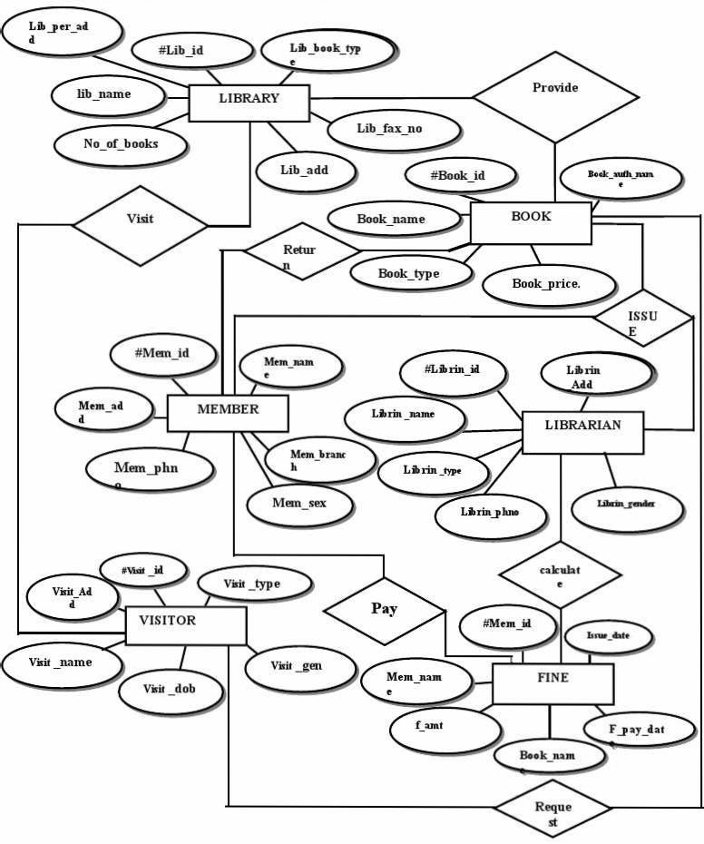**E-R Diagram**

**5.A COMPLETE STRUCTURE**

**TABLE STRUCTURE**

1. Book
2. Member
3. Visitor
4. Library
5. Librarian
6. Fine
7. Logi**n**

**1. BOOK_DETAILS**

|  |  |  |  |
| --- | --- | --- | --- |
| **SR.NO** | **Field name** | **Data type** | **Description** |
|  | **Book-id** | **Integer** | **Use for book id** |
|  | **Book_name** | **Varchar** | **Use for book name** |
|  | **Book_price** | **Varchar** | **Use for book price** |
|  | **Book_type** | **Varchar** | **Use for book type** |
|  | **Isbn_bn** | **Varchar** | **Use for book isbn no.** |
|  | **B_vol** | **Varchar** | **Use for vol. Of book** |
|  | **B_pun** | **Varchar** | **Use for book publisher** |
|  | **B_lang** | **Varchar** | **Use for book language** |
|  | **Editor** | **Varchar** | **Use for book editior** |

**2. Member Details**

|  |  |  |  |
| --- | --- | --- | --- |
| **SR.No** | **Field Name** | **Data type** | **Description** |
| **1.** | **Mem_id** | **Integer** | **Use for member id** |
| **2.** | **Mem_name** | **Varchar** | **Use for member name** |
| **3.** | **Mem_loc_add** | **Varchar** | **Use for member local addr.** |
| **4.** | **Mem_per_add** | **Varchar** | **Use for member permanent address** |
| **5.** | **Mem_phno** | **Varchar** | **Use for member phonenum.** |
| **6.** | **Mem_sex** | **Varchar** | **Use for member sex** |
| **7.** | **Mem_city** | **Varchar** | **Use for member city** |
| **8.** | **Mem_branch** | **Varchar** | **Use for member branch** |
| **9.** | **Mem_type** | **Varchar** | **Use for member type** |

**3. Librarian Details**

|  |  |  |  |
| --- | --- | --- | --- |
| **SR.NO** | **Field Name** | **Data Type** | **Description** |
|  | **Librin_id** | **Integer** | **Use for book id** |
|  | **Librin_name** | **Varchar** | **Use for book name** |
|  | **Librin_contact_no** | **Varchar** | **Use for librarian contact number** |
|  | **Librin_name** | **Varchar** | **Use for librarian name** |
|  | **Librin_gender** | **Varchar** | **Use for librarian gender** |
|  | **Librin_per_add** | **Varchar** | **Use for librarian permanent address** |
|  | **Librin_loc_add** | **Varchar** | **Use for. Librarian local address** |

**4. Fine Details**

|  |  |  |  |
| --- | --- | --- | --- |
| **SR.NO** | **Field Name** | **Data Type** | **Description** |
| **1.** | **F_id** | **Integer** | **Use for member id** |
| **2** | **Mem_name** | **Varchar** | **Use for member name** |
| **3.** | **Book_name** | **Varchar** | **Use for book name** |
| **4.** | **F_amt** | **Varchar** | **Use for fine amount** |
| **5.** | **F_pay_date** | **Varchar** | **Use for fine pay date** |
| **6.** | **F_issue_date** | **Varchar** | **Use for issue book date** |

**5. Visitor Details**

|  |  |  |  |
| --- | --- | --- | --- |
| **SR.no** | **Field Name** | **Data Type** | **Description** |
| **1.** | **Visit_id** | **Integer** | **Use for visit id** |
| **2.** | **Visit_name** | **Varchar** | **Use for visit name** |
| **3.** | **Visit_loc_add** | **Varchar** | **Use for visit local address** |
| **4.** | **Visit_per_add** | **Varchar** | **Use for visit permanent address** |
| **5.** | **Visit_phno** | **Integer** | **Use for visit phone number** |
| **6.** | **Visit_sex** | **Varchar** | **Use for visit sex** |
| **7.** | **Visit_city** | **Varchar** | **Use for visit city** |
| **8.** | **Visit_age** | **Integer** | **Use for visit age** |
| **9.** | **Visit_branch** | **Varchar** | **Use for visit branch** |
| **10.** | **Visit_type** | **Varchar** | **Use for visit type** |

**6. Login Details**

|  |  |  |  |
| --- | --- | --- | --- |
| **SR.No** | **Field Name** | **Data type** | **Description** |
| **1.** | **Log_id** | **Integer** | **Use for login id** |
| **2.** | **Log_username** | **Varchar** | **Use for login username** |
| **3.** | **Log_password** | **Varchar** | **Use for login password** |
| **4.** | **Log_type** | **Varchar** | **Use for login type** |
| **5.** | **Log_time** | **Varchar** | **Use for login time** |
| **6.** | **Log_date** | **Varchar** | **Use for login date** |

**PURPOSE, SCOPE AND APPLICABILITY**

**PURPOSE**

The purpose is to automate the existing manual system by the help of computerized equipment’s and full-fledged computer software, fulfilling their requirements, so that their valuable data/information can be stored for a longer period with easy accessing and manipulation of the book records. The required s/w and h/w are easily available and easy to work with.

**SCOPE**

**The scope of this project is as follows:**

To assist the staff in capturing the effort spent on their respective working areas.

1) To utilize resources in an efficient manner by increasing their productivity through automation.

2) The system generates types of information that can be used for various purposes.

Thus, there are information scopes behind developing the "**BOOKSTORE MANAGEMENT SYSTEM**” and it reduces a lot of burden of the entry.

**APPLICABILITY**

The Applicability of project is:

- To store the information of issue books.

- To feed information of return book.

- To access information of a particular student.

- To retrieves the information of issue and return books.

**DESCRIPTION OF FRONT END AND BACK END**

**HTML** is an initialism of Hypertext Markup Language, is the predominant markup language for web pages. It provides a means to describe the structure of text-based information in a document — by denoting certain text as headings, paragraphs, lists, and so on — and to supplement that text with interactive forms, embedded images, and other objects. HTML is written in the form of labels (known as tags), surrounded by angle brackets. HTML can also describe, to some degree, the appearance and semantics of a document, and can include embedded scripting language code which can affect the behaviour of web browsers and other HTML processors.

**CSS** Stands for "Cascading Style Sheet." Cascading style sheets are used to format the layout of [Web pages](https://techterms.com/definition/webpage). They can be used to define text styles, table sizes, and other aspects of Web pages that previously could only be defined in a page's [HTML](https://techterms.com/definition/html).

CSS helps Web developers create a uniform look across several pages of a Web site. Instead of defining the style of each table and each block of text within a page's HTML, commonly used styles need to be defined only once in a CSS document. Once the style is defined in cascading style sheet, it can be used by any page that references the CSS file. Plus, CSS makes it easy to change styles across several pages at once.

**JavaScript**

JavaScript is a script-based programming language that was developed by Netscape Communication Corporation. JavaScript was originally called Live Script and renamed as JavaScript to indicate its relationship with Java. JavaScript supports the development of both client and server components of Web-based applications. On the client side, it can be used to write programs that are executed by a Web browser within the context of a Web page. On the

server side, it can be used to write Web server programs that can process information submitted by a Web browser and then update the browser’s display accordingly.

**Bootstrap** is a free and open-source CSS framework directed at responsive, mobile-first front-end web development. It contains CSS- and (optionally) JavaScript-based design templates for typography, forms, buttons, navigation, and other interface components.

**JQuery** is a lightweight, "write less, do more", and JavaScript library.

The purpose of jQuery is to make it much easier to use JavaScript on your website.

JQuery takes a lot of common tasks that require many lines of JavaScript code to accomplish, and wraps them into methods that you can call with a single line of code.

JQuery also simplifies a lot of the complicated things from JavaScript, like AJAX calls and DOM manipulation.

The jQuery library contains the following features:

* HTML/DOM manipulation
* CSS manipulation
* HTML event methods
* Effects and animations
* AJAX
* Utilities

**Servlet:** A **servlet** is a Java programming language class that is used to extend the capabilities of servers that host applications accessed by means of a request-response programming model. Although servlets can respond to any type of request, they are commonly used to extend the applications hosted by web servers. For such applications, Java Servlet technology defines HTTP-specific servlet classes.

MySQL is a relational database system that is used to store information. MySQL can store many types of data from something as tiny as a single character to as large as complete files or graphics. Although it can be accessed by most programming languages, it is often coupled with PHP because they work together with ease.

Information stored in a MySQL database hosted on a web server can be accessed from anywhere in the world with a computer. This makes it a good way to store information that needs the ability to change over time, but also needs to be accessed over the net. Some examples that can utilize MySQL are a web message board or a customer's shipping status.

**LIMITATION OF THE SYSTEM**

Though the software presents a road range of options to its users some intricate options could not be covered into it; partly because of logistic and partly due to lack of sophistication. Lack of time also compelled me to ignore some part such as storing old result of the candidate and so on.

**The limitations of the project:**

The system has not facility for staff management.

The system does not provide accounting facility to Library.

The System can not be used for all types of Library; can be used to satisfy the requirement of a specific Library only.

The System need Windows environment with having MYSQL and JSP configuration to run.

**6. TOOLS/PLATFORM, SOFTWARE AND HARDWARE REQUIREMENT SPECIFICATIONS**

**SOFTWARE REQUIREMENTS-**

* OPERATING SYSTEM: WINDOWS, Linux etc.
* Database : MYSQL
* Front End :html css,bootstrap,js,jquery
* Backend : Servlet
* Tools : Eclipse,DreamViewer

**HARDWARE REQUIREMENTS**

* One PC at least P II,
* RAM 128 MB
* 20 GB Hard Disk,
* Colour Monitor,
* Keyboard and mouse.

**7. Are you doing this project for any Industry/Client?**

**Ans. NO.**

**8. FUTURE SCOPE AND FURTHUR ENHANCEMENT OF THE PROJECT**

In a nutshell, it can be summarized that the FUTURE SCOPE of the project circles around marinating regarding:

All the libraries can use this software very easy form.

• The information of books can be providing very easy.

•Networking administrator can be managing this software.

•Module is use to search the student issue books information.

The above mentioned points are the enhancements which can be done to increase the applicability and usage of this project

Plug-in support: plug-ins are optional software additions that enhance and/or add functionality to the main software application. With plug-in support, capable users and developers can develop their own Bookstore plug-ins, and the whole user community can benefit from that. (Bookstore will communicate with plug-ins via XML. When bookstore receives the XML stream, it will save the information to database.